4-H Science Sisters - Density of Liquids

“What will happen when a candle is placed in rubbing alcohol? What will happen if the same candle is placed in water?”

Supply Needs:
- Clear plastic cups
- Tea light candles
- Rubbing alcohol
- Water
- Cooking oil
- Corn syrup
- Syringe (empty w/o needle)
- Measuring cylinder
- Scale

Optional/Additional Needs:
- Dish soap
- Milk
- Honey
- Food Coloring

Predictions:

Candle in rubbing alcohol ____ Float ____ Sink
Candle in water ____ Float ____ Sink
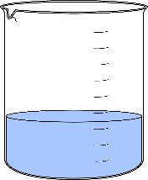
Candle in cooking oil ____ Float ____ Sink
Candle in corn syrup ____ Float ____ Sink
Candle in dish soap ____ Float ____ Sink
Candle in milk ____ Float ____ Sink
Candle in honey ____ Float ____ Sink

Density = mass/volume
*When figuring the density of water/rubbing alcohol make sure to deduct the weight of your container.

